Content:

* INTRODUCTION
* ABSTRACT
* NEED FOR THE PROJECT
* PROPOSED WORK
* BLOCK DIAGRAM
  + 1. Function of each Block as Sub headings
    2. Components used
    3. Result/Output
    4. Hardware/Software Details
* APPLICATIONS
* CONCLUSION
* PROTOTYPE OF PROJECT
* PHOTO OF TEAM MEMBERS WITH GUIDE

INTRODUCTION:

* *Spirometry is a painless test to evaluate respiratory performance by measuring how much air can be inhaled and exhaled in one force.*
* *In spirometry measurements, the quantity of air inhaled and exhaled by the patients together with the speed of the exhalation are needed to describe the conditions of lung.*
* *The device used for spirometry testing is called a spirometer. In general, a spirometer has three basic parts: mouthpiece, airflow tube and electronic device.*
* *A designed spirometer must be able of conducting analysis and diagnosis of the human respiratory system.*
* *The common function of a basic digital spirometer is to plot the expiratory air flow against total expiratory volume graph, also known as the spirogram that is used by health professionals to describe lung functions.*

ABSTRACT:

### A digital spirometer that precisely measures the lung capacity of a patient costs like a fortune for the middle class and lower class people. there are low cost spirometers that cost around the range of 5000-6000 rupees, but those spirometers use turbine sensors which are invented for the soul purpose of measuring the speed of the air passing through it where the value is converted into pressure. As the obtained value is a converted one no one can assure that the value is as precise as possible.

### so making a cost efficient spirometer is a main motive of us. even though we are making it cost efficient, we made sure that the precise values are not compromised for which we have built a spirometer using a differential pressure sensor which was exactly designed for this kind of operation.

### Our spirometer is capable of measuring the lung capacity and provides precise values of the same without any compromises even after considering the eeficiency in cost.

### .

NEED FOR THE PROJECT:

### An analog spirometer doesn’t give us a precise and a exact value or reading of our lung capacity, because of which we are required to purchase the digital variant of the meter.

### A good quality digital spirometer which doesn’t compromise the process of measuring and gives precise results cost around 20,000 INR which is not very affordable for the middle class and the lower class families and they ought to settle down compromising the results of the tests.

### And so the main objective of our idea is to reduce the cost or the amount spent on a spirometer in order to receive a precise reading of the lung capacity and to increase their lung capacity.

PROPOSED WORK:

### a pipe acts as a mouth piece to our equipment. Through the pipe the need for the pressure input is satisfied. That is nothing but the mouth piece where the patient blows to check their lung capacity.

### This pipe input is connected to an elastic tube like structure whose other end is connected to a pressure sensor that measures the pressure that is blown by the patient and converts it into a reading of lung capacity

### This pressure sensor is connected to an Arduino board that is coded with the required command. The Arduino helps in receiving the readings from the pressure sensor.

### A display unit is connected to the Arduino to display the reading to the patient.

### The ultimate goal of a spirometer is to increase the lung capacity of the patient for which we’ve also coded the Arduino to display the target breaths that has to be blown in order to achieve the target lung capacity.

BLOCK DIAGRAM:

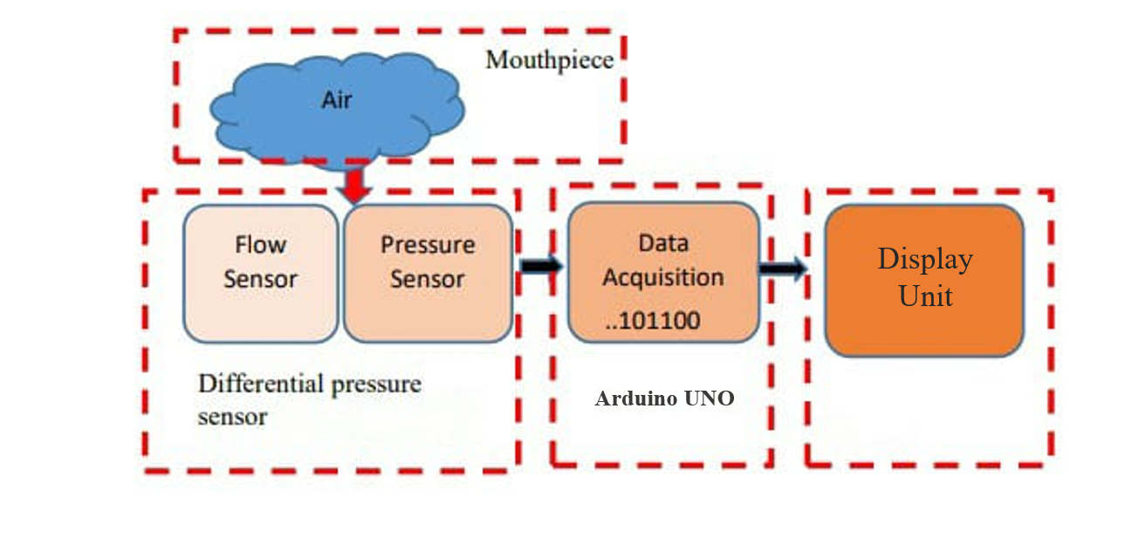

COMPENENTS USED:

**HARDWARE TOOLS:**

* Arduino Uno
* Pressure sensor (MPX10DP)
* Display Unit
* Jumper Cables
* Bluetooth Module
* Nose Clip
* Bread Board

HARDWARE/SOFTWARE DETAILS:

HARDWARE:

1.Arduino Uno:

Arduino is an**open-source platform used for building electronics projects**. Arduino consists of both a physical programmable circuit board (often referred to as a microcontroller) and a piece of software, or IDE (Integrated Development Environment) that runs on your computer, used to write and upload computer code to the physical board.

2.Pressure Sensor:

The MPX10DP is a**dual-port uncompensated silicon Pressure Sensor** for environmental control systems and level indicators. The MPX10 series silicon piezoresistive pressure sensor provides a very accurate and linear voltage output, directly proportional to the applied pressure

3.LCD Display:

LCD Display is Liquid Crystal Display and generally used in many electronics applications.In Arduino projects to show the sensor readings, status, messages we use LCD Display.In LCD 16×2 there are 2 lines with 16 characters in each line. Each character is made up of a 5×8 (column x row) pixel matrix.

4.Bluetooth Module:

HC-05 Bluetooth Module HC-05 Bluetooth Module is a low-cost, easy-to-operate & small-sized module used for wireless communication in the Bluetooth spectrum. It supports Serial Port Protocol (SPP), which helps in sending/receiving data to/from a microcontroller

SOFTWARE:

1.Arduino IDE:

Arduino is an open source electronic platform based on easy to use hardware and software.

Arduino hardware was designed for artists designers hackers and newbies in creating intracting object or environment.

CONCLUSION:

* *The spirometer is capable of distinguishing between normal and abnormal respiratory conditions from the pressure exerted during the exhale of a person.*
* *It is also capable of increasing the lung capacity by providing the target blows to be performed to attain a normal respiratory conditions.*
* *It is very much portable and is affordable and available to everyone no matter the economic background.*

Prototype Of The Project:

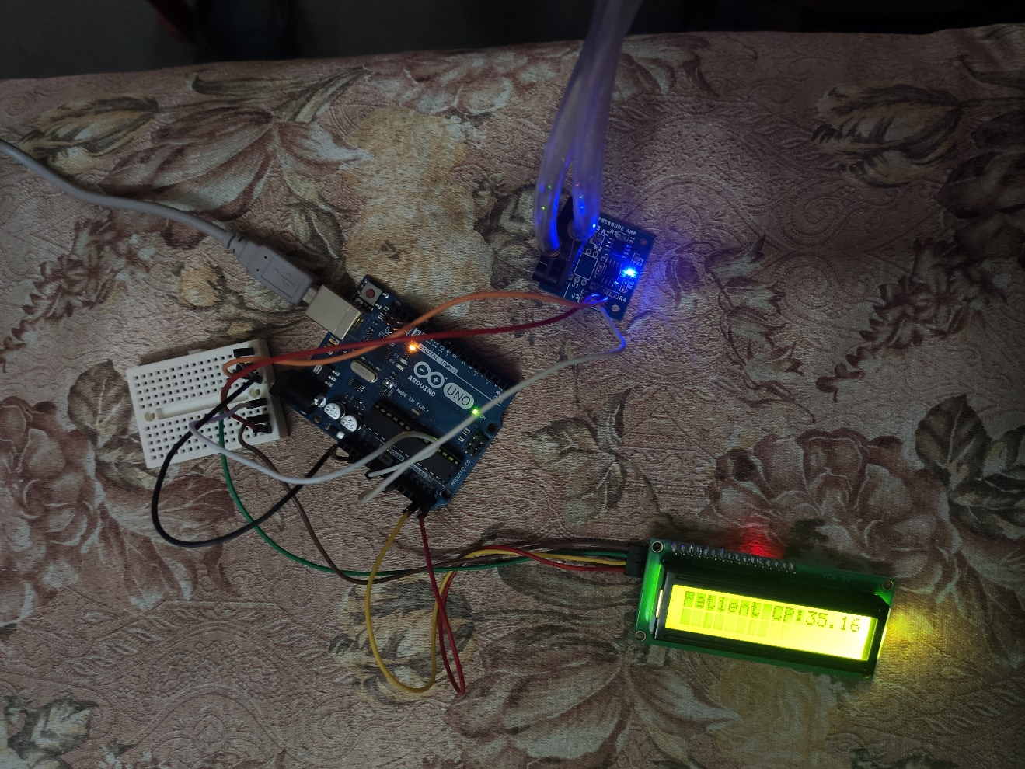

Photo Of Team Members With Guide:

